Mark Ivey

mxi240020

Friday, November 15, 2024

Project 5

Project 5: D Flip Flop

Times:

TSU_DD_ONE : -20ps (20 ps after clock edge)

TSU_OPT_ONE : 8ps (8 ps before clock edge)

THOLD_ONE :~ 30ps

TSU_DD_ZERO : 39ps

TSU_OPT_ZERO : 45ps

THOLD_ZERO : 65ps

TSU : 45 ps

THOLD : 65 ps

TD : 371ps (D low-to-high to Q)

TCLK->Q : 326ps

DFF Dimensions: 7.54 µm (width) x 3.735 µm (hight)

DFF Layout

Measurements and Contact Spacing

Figure 1: Abstract view

Methodology and Thought Process of the Layout

Figure 2: Euler Trail and Odd Nodes

In the annotated schematic above, it shows the thought process behind how I came up with two diffusion breaks and what gates I chose to connect. In the actual layout, I placed the clock in the center of the two mux/nor structures. Doing this allowed me to minimize the size of the gate; having the clock on the left or right would increase the width by 760 nm, as the metal 1 traces of CLK and $\overline{CLK}$ would have to go around the input or output.

To get the TSU_OPT, TSU_DD, THOLD, TD and TCLK->Q, I did the following:

1. First, for the case of D going high to low, I used hspice to get a rough estimate, to the nearest 100 ps, for TSU_DD
2. Then, using a script, 100-200 points were tested via a script in 1 ps increments.
3. The results were graphed and TSU_OPT, TSU_DD were determined.
4. Using TSU_OPT, I then calculated THOLD
5. The process was repeated for D going low to high
6. For the final values of TD and TCLK->Q, I used the best worst case from TSU_OPT, and THOLD. In my case, this turned out to be TSU_OPT_ZERO.

TSU_DD_ONE : -20ps (20 ps after clock edge)

TSU_OPT_ONE : 8ps (8 ps before clock edge)

THOLD_ONE :~ 30ps

TSU_DD_ZERO : 39ps

TSU_OPT_ZERO : 45ps

THOLD_ZERO : 65ps

TSU : 45 ps

THOLD : 65 ps

TD : 371ps (D low-to-high to Q)

TCLK->Q : 326ps

These values were selected because the slew rate of Q from zero-to-one was lower than one-to-zero

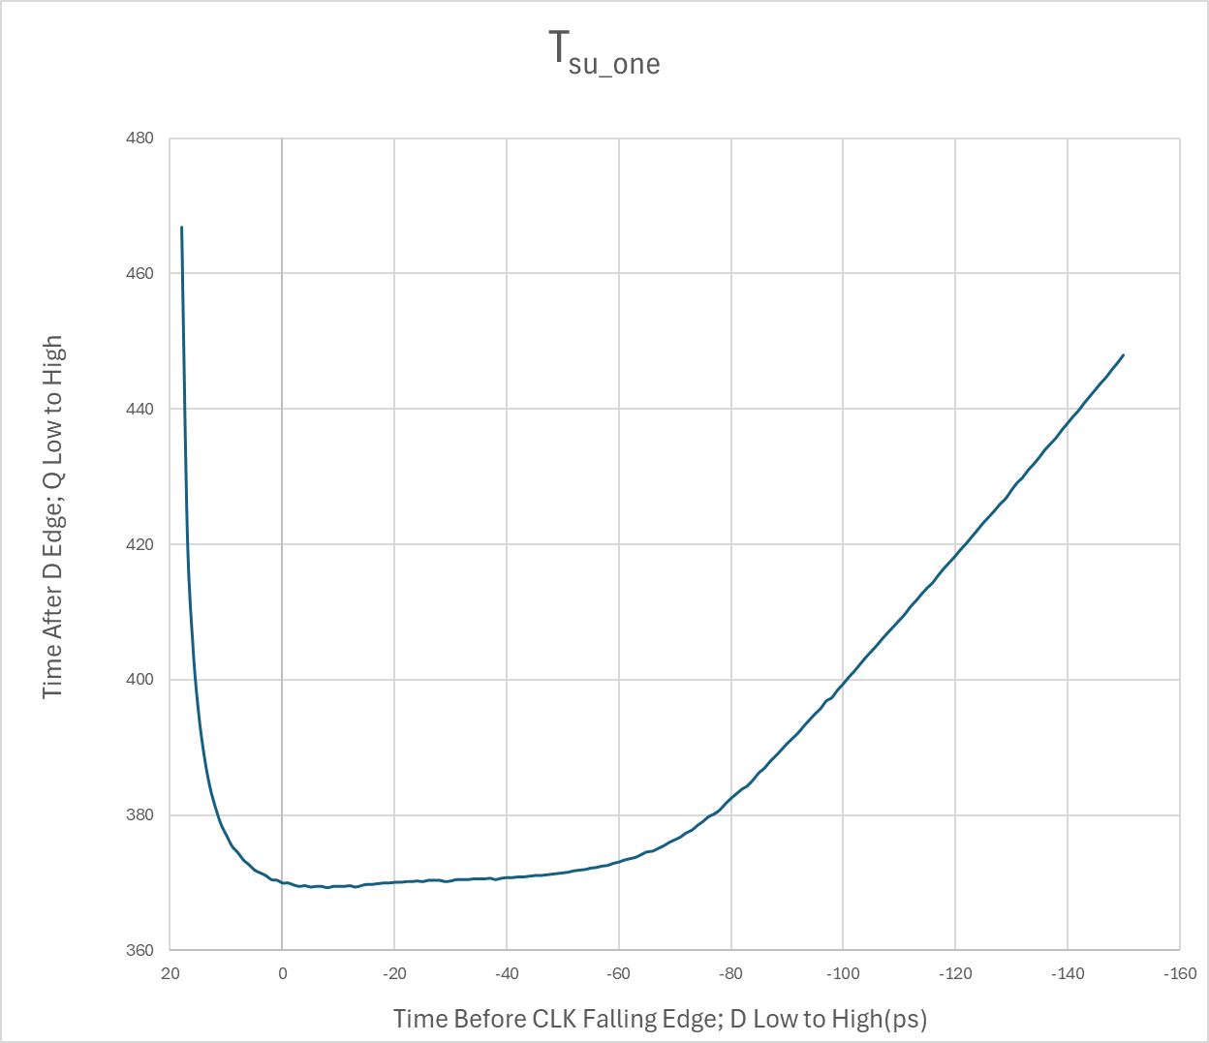

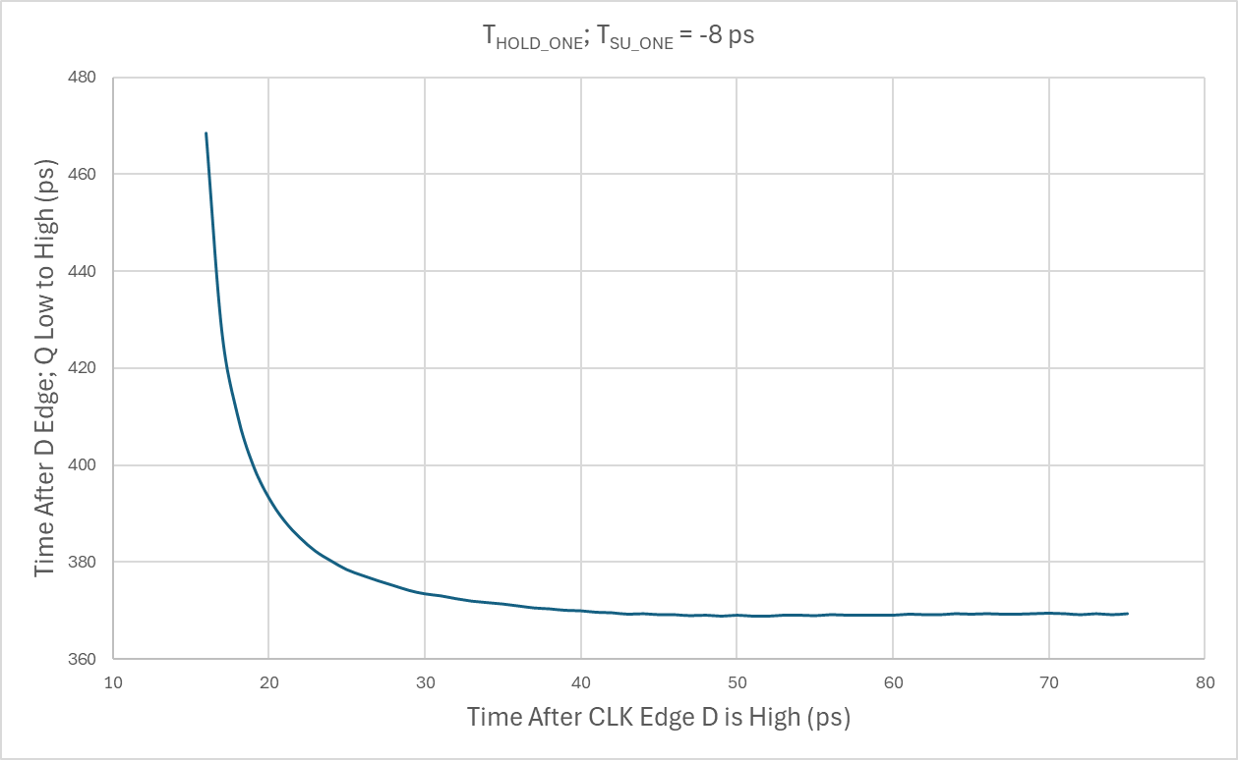

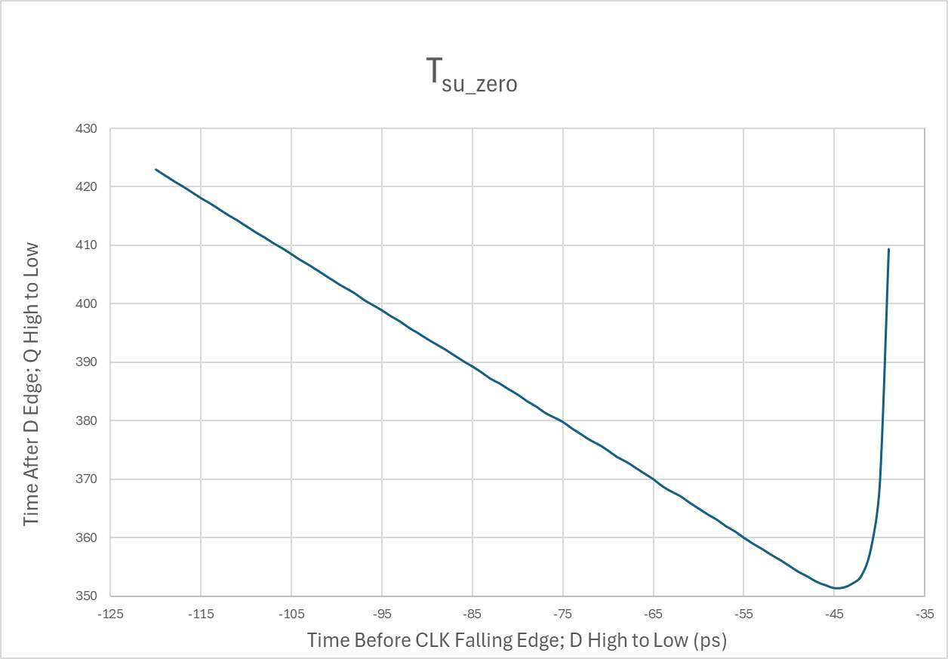

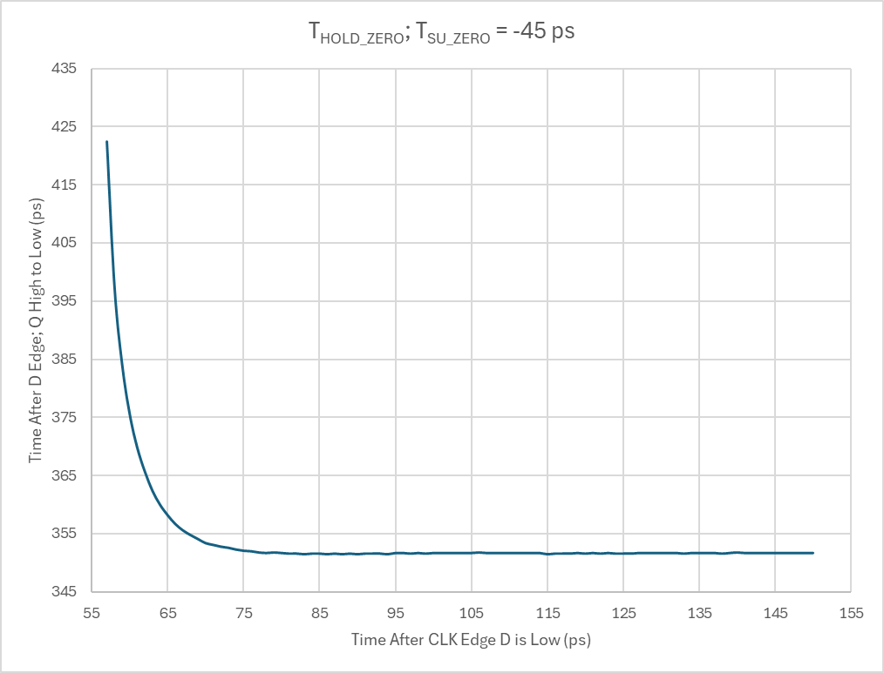

Figure 3: CLK -> Q and delay of Rising and Falling Data